Ming Hin Cheung
Technical Description -Writing for Engineering

Definition

A graphics card (also called a display card, video card, display adapter or graphics adapter) is an expansion card which generates a feed of output images to a display. Frequently, these are advertised as discrete or dedicated graphics cards, emphasizing the distinction between these and integrated graphics. At the core of both is the graphics processing unit (GPU), which is often erroneously used to refer to the video card as a whole.

Functions

For relatively low-end computer systems, the ability to create output images can be integrated into the motherboard or central processing unit . However, if you want to watch movies or play games on your computer, a dedicated video card greatly improves the quality of the graphics. For serious gamers, a high-quality video card may just be the most important part of the computer system - it's a must for rendering 3D graphics in particular.

A video card is a printed circuit board and contains its own processing unit and memory. It is like a kind of computer in itself. This essentially takes the load off the motherboard's CPU and memory to process images. The processing unit on a video card is referred to as a graphics processing unit . This is very similar to a CPU, but its design is optimized to work with images. The memory on a video card is very similar to the regular random-access memory on a motherboard. A video card connects to the motherboard of a computer system using a slot, typically an Accelerated Graphics Port or a Peripheral Component Interconnect Express connection.

High-performance video cards generate a lot of heat. Video cards therefore need to employ heat sinks, which consist of metal strips to distribute the heat evenly and dissipate the heat into the surrounding air. A heat sink is often located right on top of the GPU. Sometimes a fan is added for additional cooling.

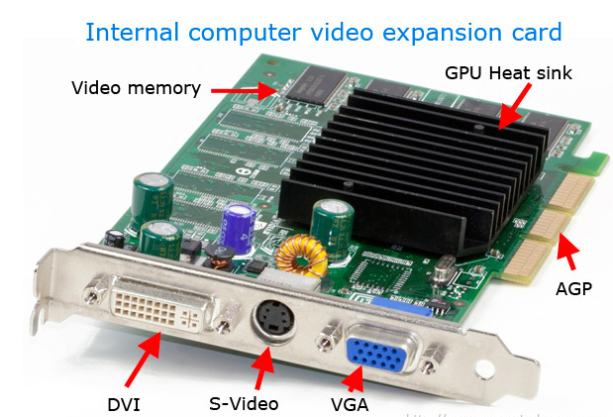

Types

Integrated

If you have a computer, but did not assemble it yourself or upgrade it in any way, chances are that it uses an integrated graphics card to display images on your screen. When a graphics card is described as integrated, it refers to the card's relationship with the computer's motherboard. Integrated graphics cards, sometimes known as on-board graphics cards, are the default option that comes with standard motherboards. An integrated graphics card can be upgraded, but it requires plugging a new graphics card into your computer's motherboard and having the computer ignore the old card.

Integrated graphics cards are the least powerful variety overall, at least compared to the technology that exists simultaneously. If you have an integrated graphics card and want to play the latest video games, you will need to upgrade.

PCI

PCI graphics cards are cards that use the PCI slots on your motherboard to connect to your computer. PCI graphics cards are usually a little bit out of date, if not extremely so. However, many older motherboards have PCI slots and lack newer varieties of connections. For this reason, there is still a reason to buy a PCI graphics card, but only if you are trying to upgrade an older system.

AGP

AGP graphics cards are named for the same thing PCI cards are—the slot they connect to on a motherboard. AGP cards can have four speeds, the fastest being 8x. However, if your motherboard only supports a lower speed, such as 1x, 2x, or 4x, your graphics card will behave as if it is of a slower speed, rather than its real speed. AGP connections are not quite as fast as PCI-E slots due to technological limits, and as a result will not be developed to run at higher speeds. However, like PCI cards, they are more widely compatible than the most cutting-edge cards.

PCI-Express

PCI-E cards are the most advanced, connecting to the motherboard's PCI-E slot. PCI-E graphics cards can be accelerated to 16x. In addition, a motherboard with more than one PCI-E slot can have more than one PCI-E graphics card connected to it and combine their power. However, this is a rare scenario. This can also cause compatibility problems if not planned out correctly; certain motherboards work better with specific brands of PCI-E video card.
Ports
The picture above is an example of a video card with three connections, or video ports, on the back.

-VGA connector
-S-Video connector
-DVI connector

In the past, VGA or SVGA was the most popular connection used with computer monitors. Today, most flat panel displays use the DVI connector or HDMI connector (not pictured above).

Expansion Slots

In the picture above, the video card is inserted into the AGP expansion slot on the computer motherboard. Over the development of computers, there have been several types of expansion slots used for video cards. Today, the most common expansion slot for video cards is PCIe, which replaced AGP, which replaced PCI, which replaced ISA.

Citations

J. Strickland, “What's inside my computer?,” HowStuffWorks, 23-Sep-2008. [Online]. Available: https://computer.howstuffworks.com/inside-computer1.htm. [Accessed: 02-Apr-2019].

T. Fisher, “What Is PCI Express?,” Lifewire, 07-Jan-2019. [Online]. Available: https://www.lifewire.com/pci-express-pcie-2625962. [Accessed: 02-Apr-2019].

“What is a Video Card?,” Co\mputer Hope, 13-Nov-2018. [Online]. Available: https://www.computerhope.com/jargon/v/video-card.htm. [Accessed: 02-Apr-2019].

